Assignment 2

1. Maximum flow problem

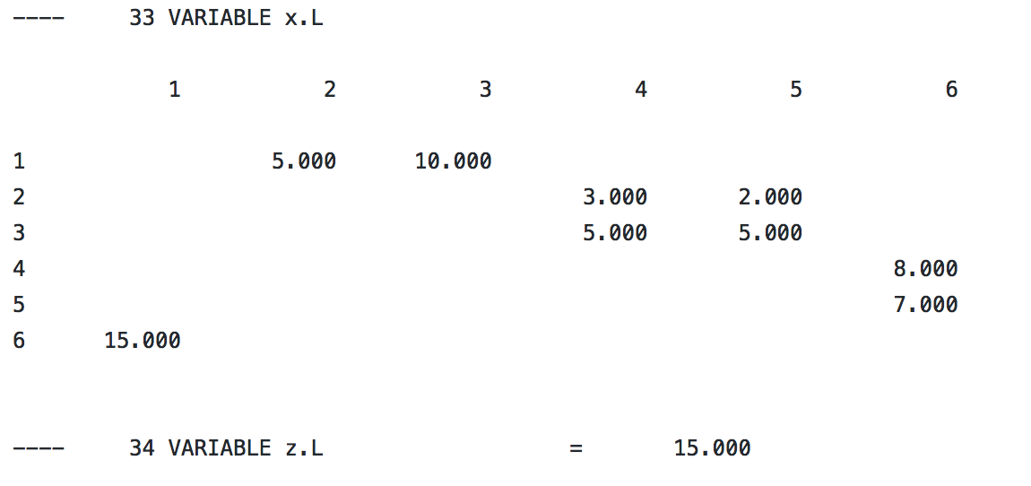

1. Mini-cost

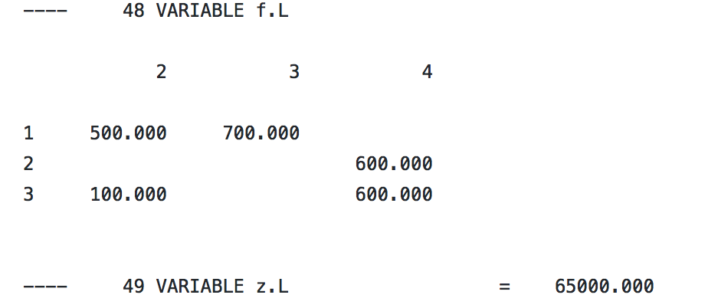

The decision variables are sum of the cost z.

1. Integer programming model: branch and bound

Integer:

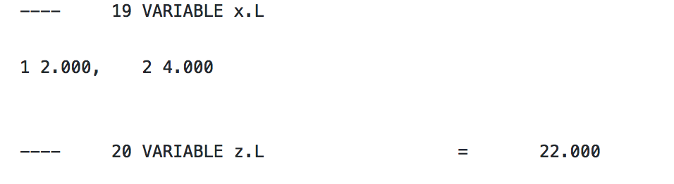

LP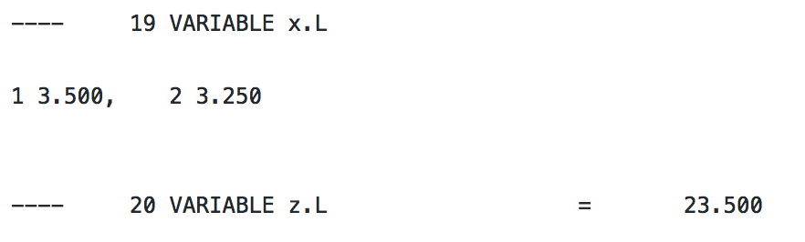

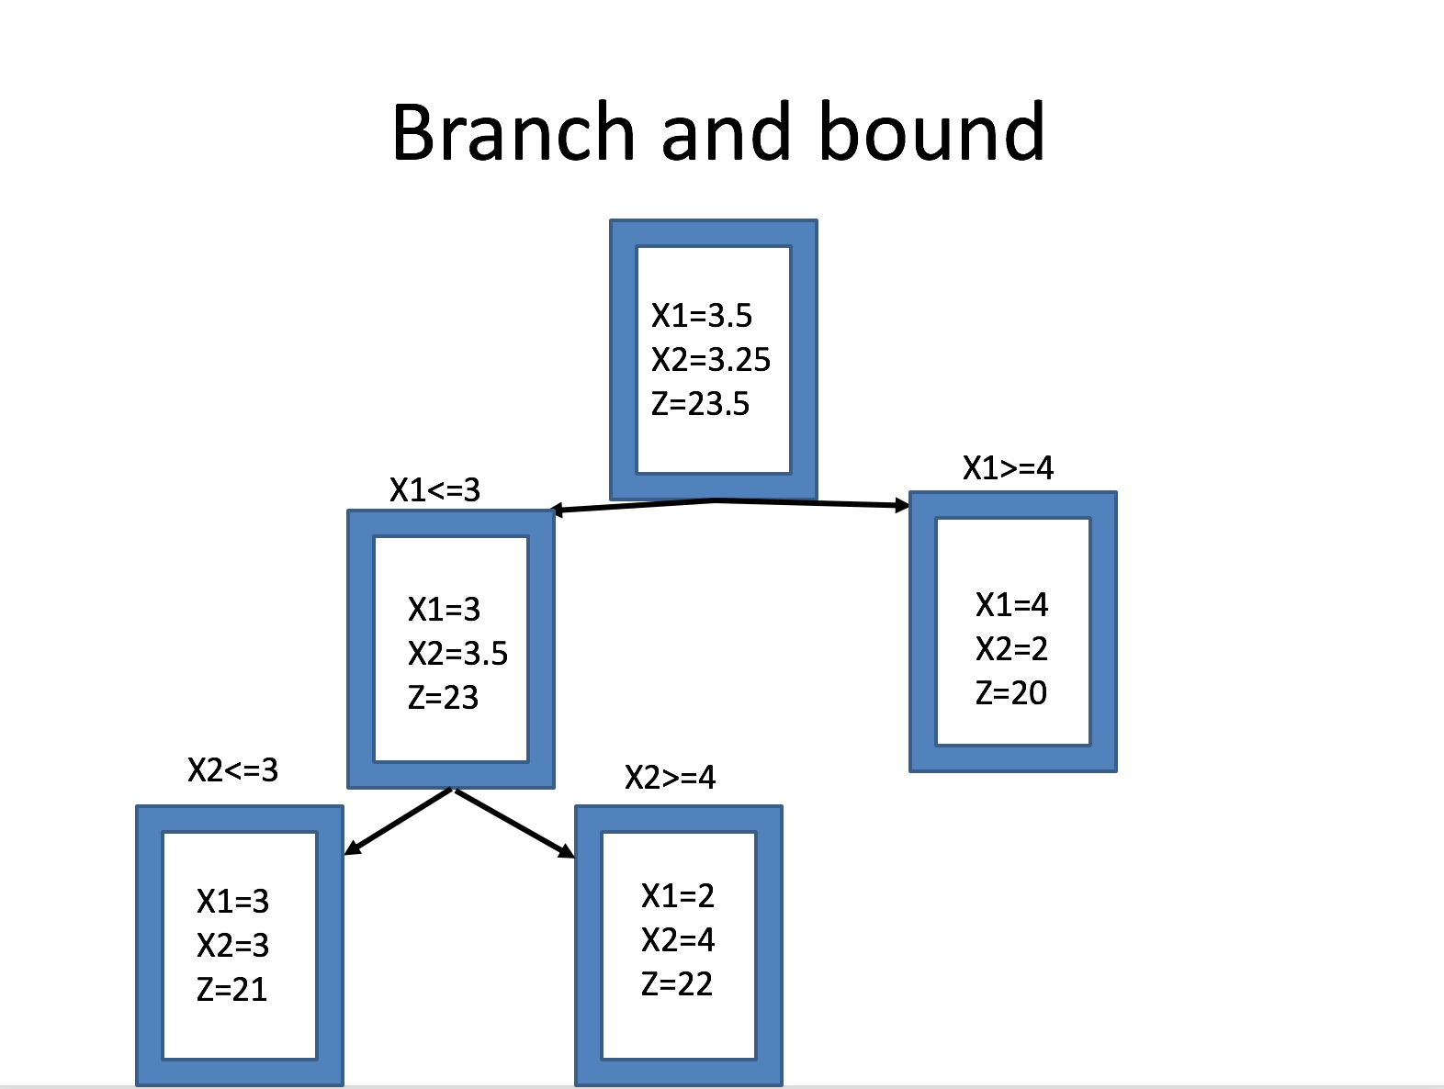

1. Warehouse

